Xia Yongqing，Ph.D.，Associate Professor，Master Tutor.

Email: [xiayq@upc.edu.cn，Mobile number: 15853275686](mailto:xiayq@upc.edu.cn，Mobile%20number:%2015853275686)

**Academic Experience**

2002-2007 *Ph.D.*, *Polymer Chemistry&Physics*,Nankai University, Tianjin 2009- *Associate Professor, Chemical Engineering College*

2015-2016 Visiting Scholar, UCLA

**Research area：**

1. The Application of Intelligent Hydrogels/Microgels in Biomedical Area.

  C:\Users\Administrator\Desktop\图片2.tif

1. The Application of Biomimetic Materials in Biosensor and Wearable Devices. 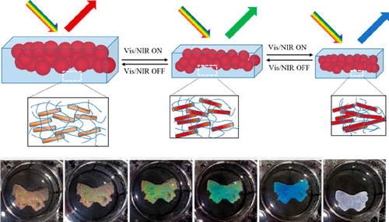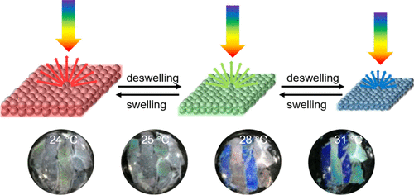

**Research projects:**

Natural Science Foundation of Shandong Province (ZR2020MB076)

Natural Science Fund of Shandong Province(ZR2015BM013)

Natural Science Foundation of China (20804057)

**近三年代表性论文**

1. Zhujun Zeng, Jinhui Liang, Ronghua Yu, Jiahui Liu, Meiwen Cao, Shengjie Wang, * and Yongqing Xia*. ACS Appl. Mater. Interfaces 2021, 13, 25563−25570.
2. Yongqing Xia,* Shuai Gao, Ronghua Yu, Zhujun Zeng, Hua He, Xiaohan Zhou, Ying Hu, Meiwen Cao, and Shengjie Wang. ACS Applied Polymer Materials 2021 3 (2), 757-764.
3. Yongqing Xia,* Shuai Gao, Hua He, Xiaojuan Wang, Zhujun Zeng, Binghe Chen, Nianjun Zou, Meiwen Cao, and Shengjie Wang. * J. Phys. Chem. C 2020, 124, 16083−16089.
4. Yongqing Xia,* Dachao Tang, Zhujun Zeng, Xiaojuan Wang, and Shengjie Wang. ACS Appl. Bio Mater. 2020, 3, 8551−8558.
5. Dachao Tang, Zhujun Zeng, Yongqing Xia, * Binghe Chen, Shuai Gao, Meiwen Cao, Shengjie Wang, Dongxiang Li. J. APPL. POLYM. SCI. 2020, DOI: 10.1002/APP.48773
6. Yongqing Xia,* Binghe Chen, Shuai Gao, Yijing Liu, Zhujun Zeng, Meiwen Cao, and Shengjie Wang. * Adv. Mater. Interfaces 2019, 1901363.